PRESS RELEASE: THE PERFECT URBAN LIGHT?
PUT IT ON YOUR SEAT POST. PLUS YOUR STEM BOLT. PLUS YOUR FORKS. PLUS YOUR SOCK. PLUS YOUR SHIRT. PLUS YOUR HELMET. PLUS YOUR TENT. PLUS…

+ [video]

The “Plus” light is the holy grail for riders and retailers. A sub-$20 USB-rechargeable light with a small format and a mighty output. The COB LED technology makes this light one of the brightest be-seen lights around.

What’s more, it’s wearable.

Slip it on your bag, or back of shirt for ideal visibility. But the best position for the rear is one in each sock. Research findings published in the Proceedings of the Human Factors and Ergonomics Society have shown that cyclists with lights attached to each foot are likely to be recognized (as a cyclist) from over 3x the distance as when the light is static on the bike. That’s why Knog have a limited time “Biomotion” special offer on their website which includes two rear Plus.

Its mounting system is one of a kind too – a simple bracket that holds onto the light with a mix of mechanical and magnetic force (1kg pull weight). This mean you can simply pop it on and off, but it doesn’t shake out of the mount on the ride. And the front light can fit in front of most stem bolts for that central position so sought after. USD $19.95

For imagery and spec see here: bass.knog.com.au

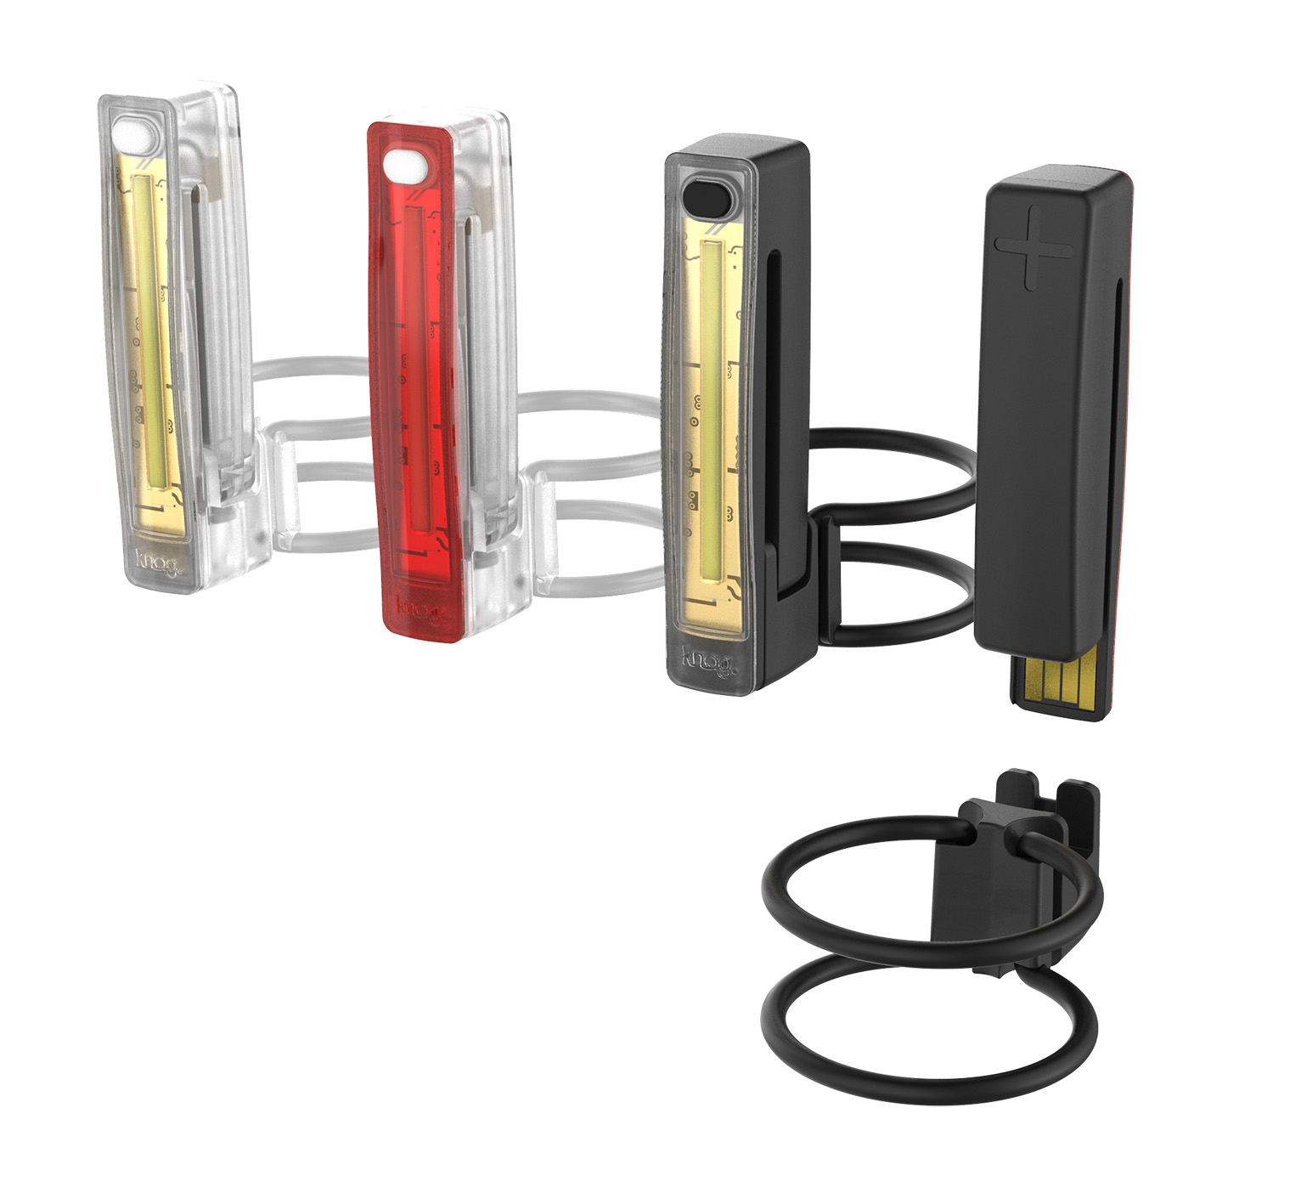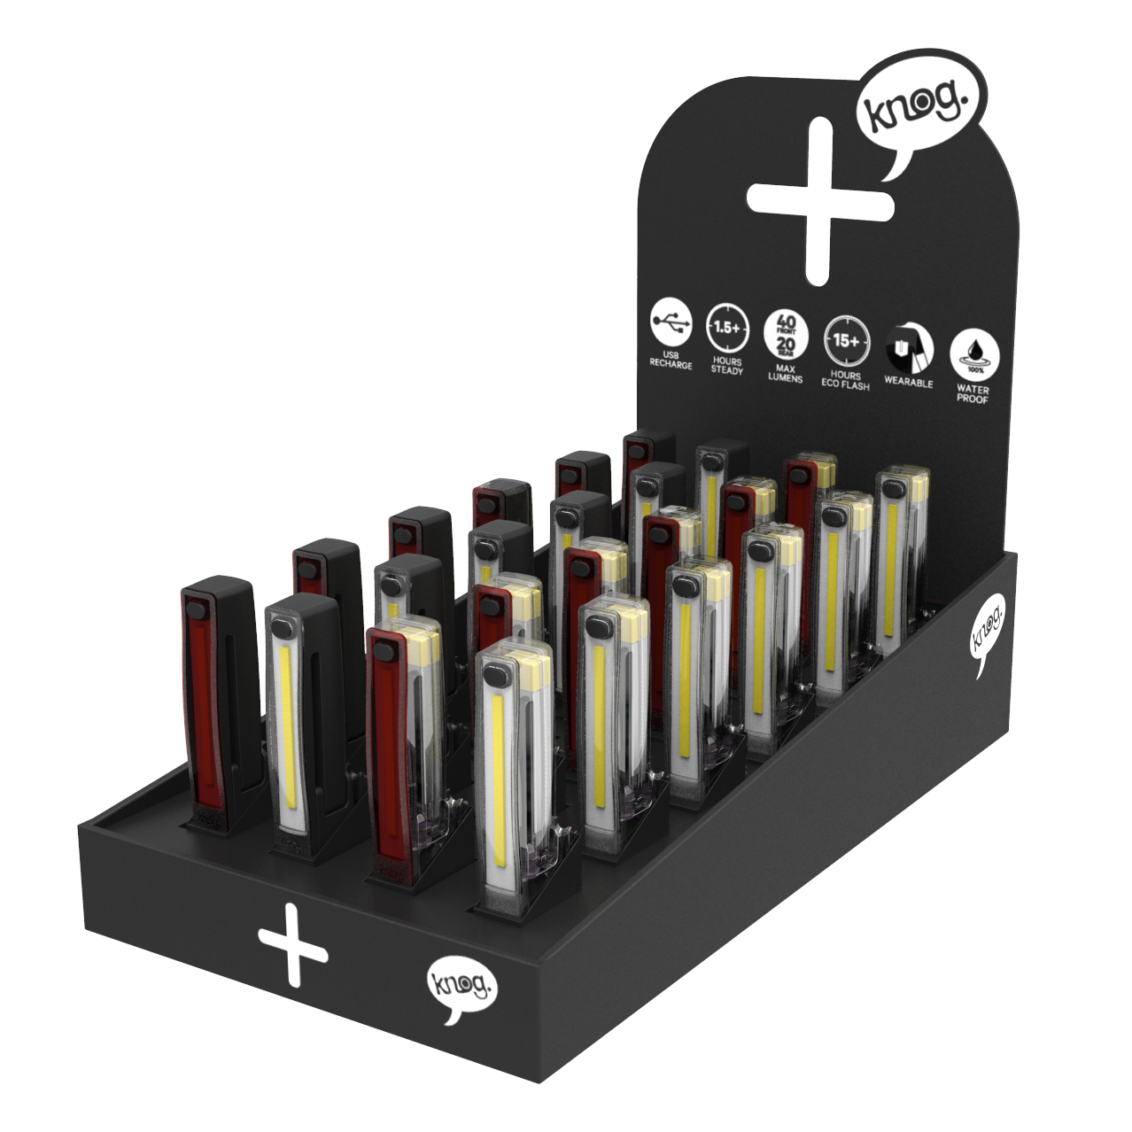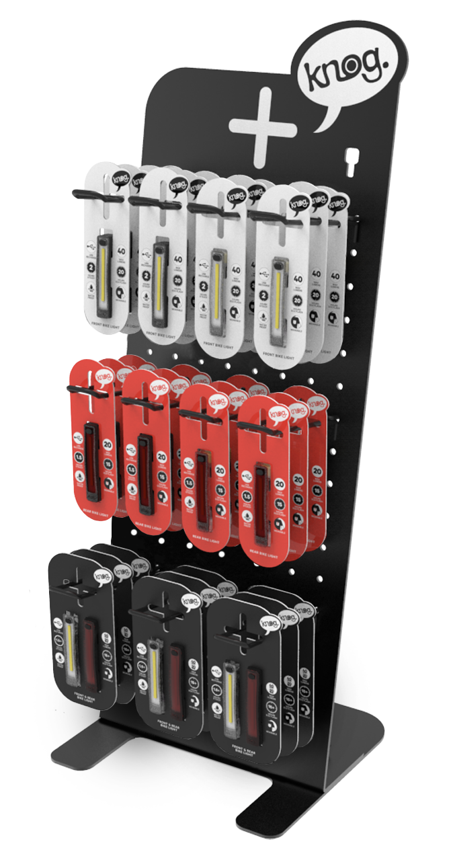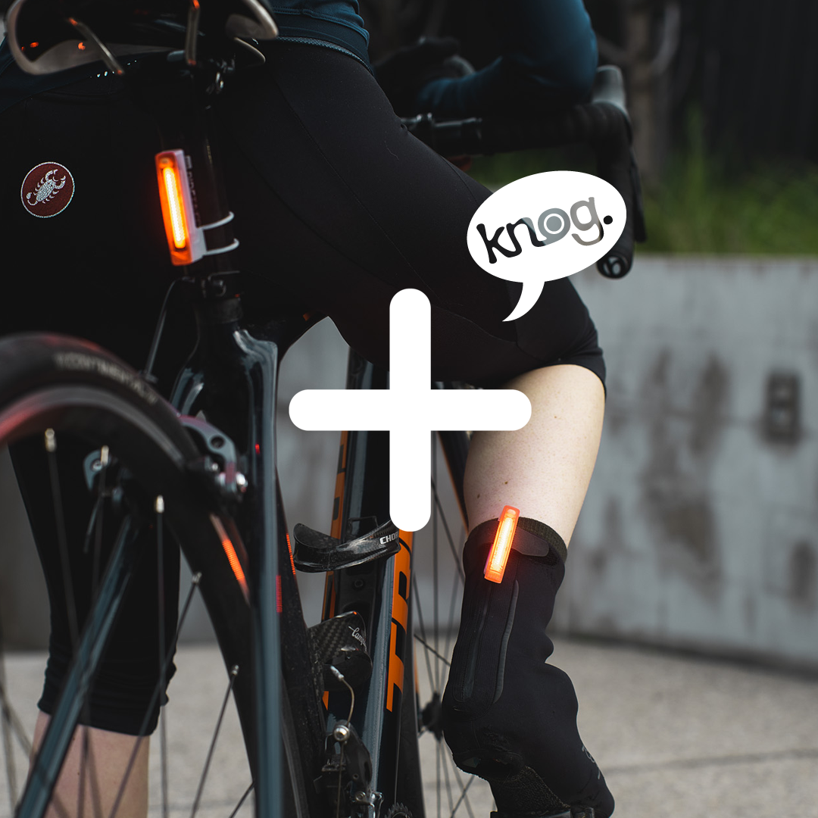

To learn more see Knog’s Plus landing page: knog.com.au/plus
Or email Sam Moore, Head of Brand & Marketing: sam@knog.com.au

